**Cancer Coding Service**

Requirements

1. Windows 2016 Server
2. MS SQL Server 2016 with SQL Management Studio

MS SQL Server Express 2017 download location

<https://www.microsoft.com/en-us/download/details.aspx?id=55994>

MS SQL Server Management Studio 2017 download location

<https://docs.microsoft.com/en-us/sql/ssms/download-sql-server-management-studio-ssms?view=sql-server-2017>

**Configure Windows 2016 Server to serve ASP.NET based Web API**

Add the following roles and features

1. Add the Web Server Role, then under Web Server expand Application Development and select .NET Extensibility 4.6 and ASP.NET 4.6

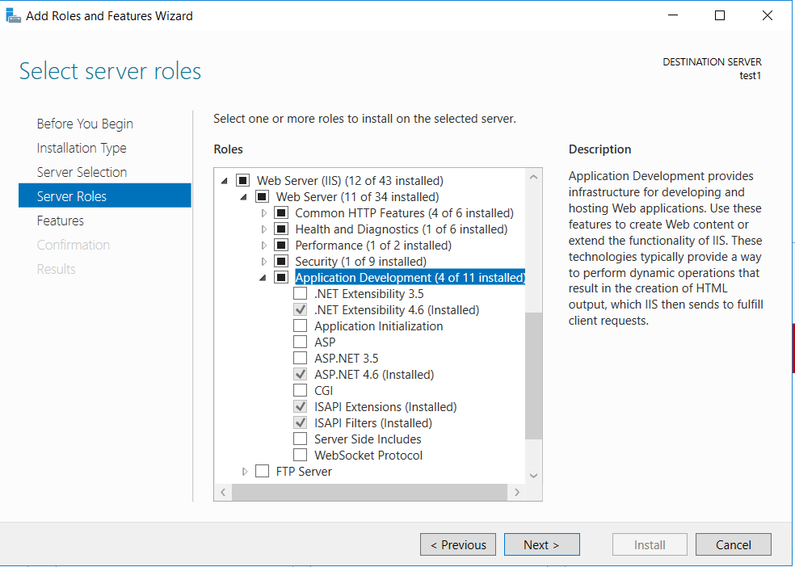

1. In Features selection step under .NET Framework 4.6 Features make sure ASP.NET 4.6 is selected.

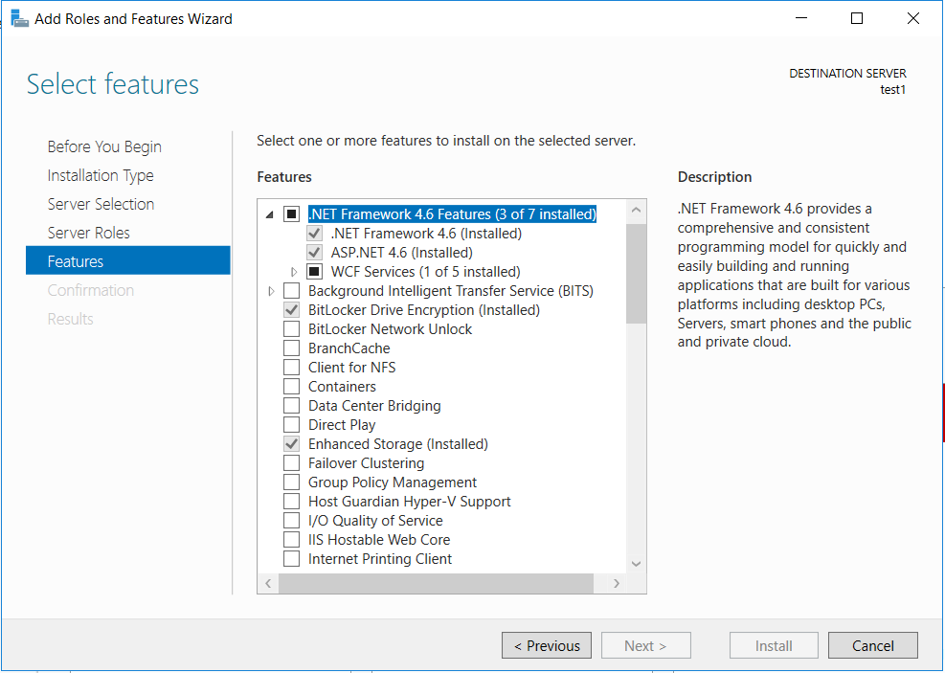

**Database setup**

1. Open Command Prompt
2. Type: sqlcmd –s computer_name\sqlexpress – i path_to_script\scripts.sql, hit enter and wait for the command to complete.

**IIS Setup**

1. Create CancerRegistryCodingService folder under C:\Inetpub\wwwroot and copy all files and folders from binaries folder of the repo to C:\Inetpub\wwwroot\CancerRegistryCodingService.
2. Open IIS Manager, create CancerRegistryCodingService application folder under Default Web Site and point the physical location to C:\Inetpub\wwwroot\ CancerRegistryCodingService

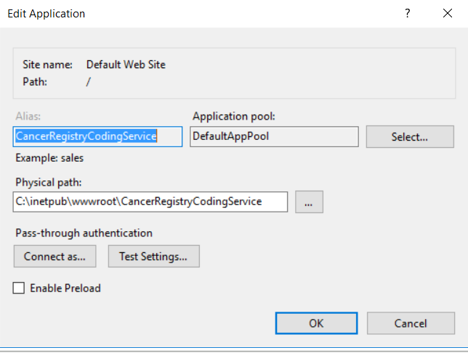

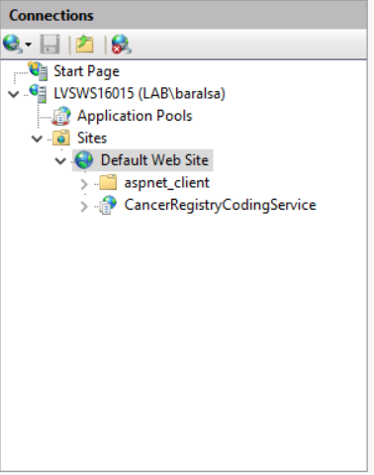

**Configure Connection to Database**

Open web.config file in C:\Inetpub\wwwroot\ CancerRegistryCodingService, and change the database connection string in the following line to point to the SQLExpress on this server.

<add name="eMaRCPlus" connectionString="Server=computer_name1\SQLEXPRESS;Integrated Security=true; Initial Catalog=CancerRegistryCoding; MultipleActiveResultSets=true;" providerName="System.Data.SqlClient" />